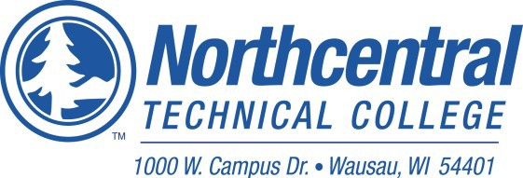

DUAL CREDIT INSTRUCTOR APPLICATION

Return to: Northcentral Technical College – Tracy Ravn 1000 W. Campus Dr., Wausau, WI 54401
715.803.1782 or 1-888-NTC-7144, ext. 1782
Web site: www.ntc.edu Email: ravn@ntc.edu

NTC Dual Credit Course: Course Number:

Full Name

Address:

Number and Street City, State, Zip County

Email Address (work):

Email Address (home): ___________________________________________________________________

Telephone (Home) Telephone (Cell)

Have you ever been employed at NTC? Yes No
If yes, please provide dates and position

Education
Degree 1/Date Earned/School
Major:
Minor:
Related Coursework:

Degree 2/Date Earned/School
Major:
Minor:
Related Coursework:

Do you hold a Master’s Degree:

If Yes, what is it in:

Do you have an additional 18 graduate credits in your program of study?

Certifications and or Professional licenses: Please list any professional certifications or licenses you hold.

Teaching Experience:

School District/Dates from-to

School District/Dates from-to

School District/Dates from-to

Occupational Experience;
Current Employer: Job Title School

Job Title 1/Company/Dates from-to

Job Title 2/Company/ Dates from-to

APPLICANT’S STATEMENT
I certify that all answers given herein are true and complete to the best of my knowledge. Please submit a copy of your DPI License and an unofficial copy of your Transcripts.

Signature of Applicant Date

Northcentral Technical College does not discriminate on the basis of race, color, national origin, sex, disability or age in employment, admissions or its programs or activities. The following person has been
designated to handle inquiries regarding the College’s nondiscrimination policies: Equal Opportunity Officer, Northcentral Technical College, 1000 W. Campus Drive, Wausau, WI 54401, Phone: 715.803.1057

