Central Wisconsin Fall Caregiver Conference
Speaker Biographies

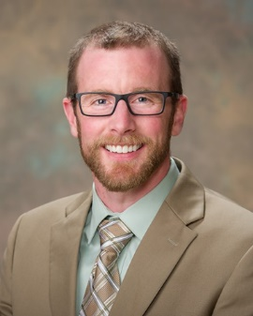
Peter Keenan, Psy.D., LP, Clinical Neuropsychologist, Marshfield Clinic

Dr. Keenan completed his Masters and Doctorate degrees in psychology from the University of St. Thomas, Minneapolis, MN. He then completed his neuropsychology internship with the Illiana VA Health Care System in Danville, Illinois and his neuropsychology residency at the Minneapolis VA Health System. He has practiced at Marshfield Clinic’s Minocqua Center since 2016.

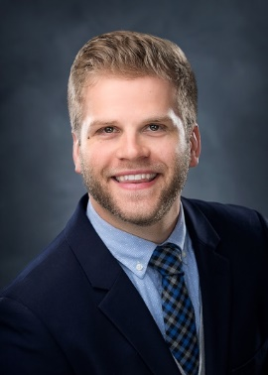
Brian D. Weiland, Psy.D., Licensed Clinical Psychologist, Co-Owner, Behavioral Health Clinic
Dr. Brian Weiland is a Licensed Clinical Psychologist and co-owner of the Behavioral Health Clinic located in Wausau and Plover, WI. He has done numerous local news segments ranging from death and dying, to school violence, to fostering healthy relationships. He works with individuals, families, couples, and groups, specializing in grief, relationship issues, trauma, and self-esteem. He also performs psychological and neuropsychological evaluations for various mental health disorders including AD/HD, personality disorders, Bipolar disorder, and others.

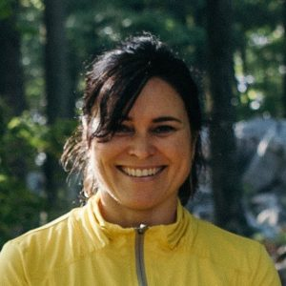
Heather Van Dalfsen, 5 Kosha’s Wellness and Yoga
Heather Van Dalfsen is a Yoga Therapist, Viniyoga Teacher and Managing Partner at 5 Koshas Yoga and Wellness in Wausau Wisconsin. Heather’s intention is to provide you with a safe and welcoming space to learn accessible and effective yoga techniques to support your physical, mental and emotional health. Techniques include: mindful movements, breathing techniques, guided meditation and setting a personal intention.

