**NTC Welding Contest - 2025**

**REGISTRATION**

The Online Registration form will be available at: <https://www.ntc.edu/calendar/2025/05/08/welding-competition> .

You’ll also find key dates and the agenda for the day on that page.

# ENTRY DIVISIONS

Prizes will be awarded in two separate divisions – Utilitarian entries and Artistic entries.

*Both types of entry must conform to the project parameters listed below.*

*Utilitarian projects* serve a specific function. (can crusher, bench vise, grill, etc.)

*Artistic projects* have a purely aesthetic value. (abstract or representational sculpture, scale models, etc. )

# PROJECT PARAMETERS

# TEAMS

Participating teams may have a 1 - 6 members. Schools can have multiple teams.

# FABRICATION

Your project must include fillet welds and at least one groove weld.

# Welding, cutting and forming processes may be manual, semi-automatic, or CNC.

# SIZE

Your *assembled* project’s overall footprint must be 20 cubic feet or smaller.

*Your project may fit in 2’ x 2’ x 5’ space, or a 1’ x 2’ x 10’ space, or some other 20 cubic foot space*.*

*\* See SIZE LIMITATION illustration.*

# FINISHING

Do not grind your finished welds or paint your project. Your welds must be visible so that the judges can evaluate them.

# DOCUMENTING YOUR PROJECT – ELECTRONIC PORTFOLIO

Document your project to show the steps you took from beginning to end. Your portfolio can include photos, video, drawings, and/or written descriptions. Use Google Slides or Microsoft Powerpoint to create your electronic portfolio. A sample portfolio will be available for reference. Submit your portfolio by the deadline listed in “Key Dates”.

Photos/Video/Drawings/Documents in your electronic portfolio must include the following:

Your school, team name, team members, instructor, and the division you’re entering.

The inspiration and intent behind your project

The function of your project (Utilitarian Entries)

Conformance of your project to the size requirement

Your project timeline and the steps you took

The processes, tools, and techniques you used in your project

Your fit up before welding, and the methods you used to preserve critical dimensions and geometric features such as squareness, straightness, flatness, perpendicularity, etc.

Your weld processes, quality and size

The challenges you encountered and solutions you employed

# PRESENTING YOUR PROJECT

At NTC, each team will give a 2 to 3 minute presentation about its project. Presentation points may include the specific purpose or function of your project, the steps your team took to complete the project, the challenges your team encountered, and what you learned or accomplished in the process. The contest judges will be present for presentations, and will likely ask questions after each team’s presentation.

# JUDGING

Your project will be rated in the four categories below. See “Judging Criteria” for more details.

|  |  |
| --- | --- |
| **Category** | **Possible Points** |
| **Design** | **30** |
| **Portfolio** | **20** |
| **Presentation** | **10** |
| **Craftsmanship** | **40** |
| ***total*** | **100** |

**SIZE LIMITATION**

Entries will be measured in their *fully assembled* state. The *overall footprint* must be 20 ft3 or less. *(L x W x H)*

Here is an example …….

L x W x H ≤ 20 ft3

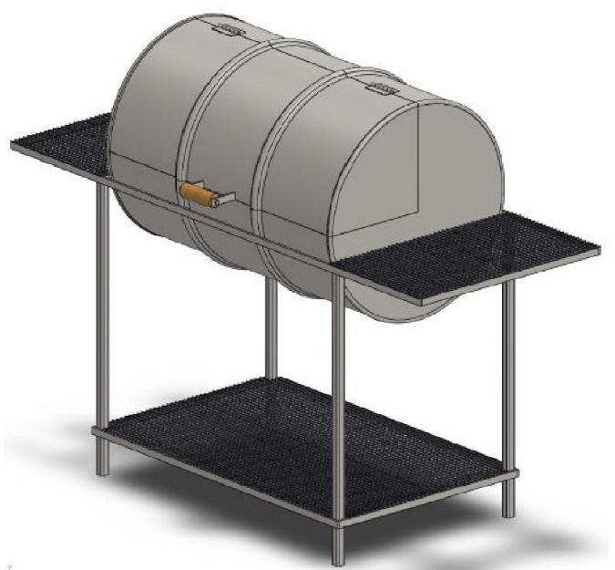

***Length***

***Width***

***Height***

|  |  |  |  |  |  |  |  |  |  |  |  |
| --- | --- | --- | --- | --- | --- | --- | --- | --- | --- | --- | --- |
| **JUDGING CRITERIA** |  | **SCORES** | | | | | | | | | |
|  |
| **DESIGN** |  | **Sub** | **Basic (C)** | | **Good (B)** | | **Excellent (A)** | | |  | |
| Your design lends to the efficient function of your project (Utilitarian)  **- or -**  Your design lends to the aesthetic impact of your project (Artistic) |  | ≤  6.5 | 7 | 7.5 | 8 | 8.5 | 9 | 9.5 | 10 | ***total*** | |
| Your process/tool choices support your design intent |  |  |  |  |  |  |  |  |  | ***x 3*** |  |
| Your material/technique choices support your design intent |  |
| **PORTFOLIO** |  | **Sub** | **Basic (C)** | | **Good (B)** | | **Excellent (A)** | | |  | |
| Your portfolio shows the evolution of your project, from start to finish |  | ≤  6.5 | 7 | 7.5 | 8 | 8.5 | 9 | 9.5 | 10 | ***total*** | |
| Your portfolio details the processes, tool, and techniques you used |  |  |  |  |  |  |  |  |  | ***x 2*** |  |
| Your portfolio shows the function of your project |  |
| **PRESENTATION** |  | **Sub** | **Basic (C)** | | **Good (B)** | | **Excellent (A)** | | |  | |
| You clearly explain the inspiration and intent behind your project |  | ≤  6.5 | 7 | 7.5 | 8 | 8.5 | 9 | 9.5 | 10 | ***total*** | |
| You clearly describe the processes, tools, and techniques used |  |  |  |  |  |  |  |  |  | ***x 1*** |  |
| You reflect on challenges and lessons learned throughout the project |  |
| **CRAFTSMANSHIP** |  | **Sub** | **Basic (C)** | | **Good (B)** | | **Excellent (A)** | | |  | |
| Your weld processes serve your design intent, welds are free of defects |  | ≤  6.5 | 7 | 7.5 | 8 | 8.5 | 9 | 9.5 | 10 | ***total*** | |
| Your cut processes serve your design intent and are well executed |  |  |  |  |  |  |  |  |  | ***x 4*** |  |
| Your fit up preserves critical dimensions and geometric features |  |
|  |  | ***TOTAL POINTS*** | | | | | | | | |  |

**JUDGING CRITERIA - WELDS**

|  |  |  |
| --- | --- | --- |
| **The following discontinuities will be considered defects for the purpose of this Contest** | | |
| **Voids, Cracks & Inclusions** | Undercut | Greater than 1/32” in depth, any length |
| Porosity | Sum of diameters of holes equals 1/4” or more on entire project |
| Cracks | Any |
| Slag inclusions | Any |
| **Size & Contour** | Convexity or Concavity | 3/32” or greater, any length in any location |
| Unequal Leg (Fillets) | Greater than 1/16”, any length in any location |
| Appropriate Size (Fillets) | Leg size = thickness of thinner member |
| Underfill (Groove Welds) | Greater than 1/32” in depth, any length |
| Reinforcement (Groove Welds) | Greater than 1/8”, any length |
| **Finish** | Lack of finish | Slag, wire stubs, or weld spatter in any amount |