NTC Welding Contest - 2026

REGISTRATION
Register on the Welding Competition Website

TEAMS
Participating teams may have one to six members. Schools can have multiple teams.

KEY DATES:
- Registration Deadline: April 6, 2026
- Portfolios Due: April 24, 2026
- Competition Date: May 7, 2026

ENTRY DIVISIONS
Prizes will be awarded in three separate divisions:

UTILITARIAN
Utilitarian projects serve a specific function. Examples include projects like a can crusher, bench vise, grill, etc.

ARTISTIC
Artistic projects have a purely aesthetic value. Examples include projects that are abstract like a representational sculpture, a scale model, etc.

FIRST-TIME COMPETITOR
This division is for individuals or teams whose members have not previously entered the NTC Welding Contest. First-Time Competitor entries can be either utilitarian or artistic. Please note that teams that include past participants are not eligible for this division.

PROJECT PARAMETERS
All entries must conform to the project parameters listed below.

FABRICATION
Your project must include fillet welds and at least one groove weld. Welding, cutting and forming processes may be manual, semi-automatic, or CNC.

FINISHING
Do not grind your finished welds or paint your project. Your welds must be visible so that the judges can evaluate them.

SIZE
Your assembled project’s overall footprint must be 30 cubic feet or smaller. Entries will be measured in their fully assembled state. The overall footprint must be 30 cubic feet or less. This is calculated using the formula Length times Width times Height = X Cubic Feet
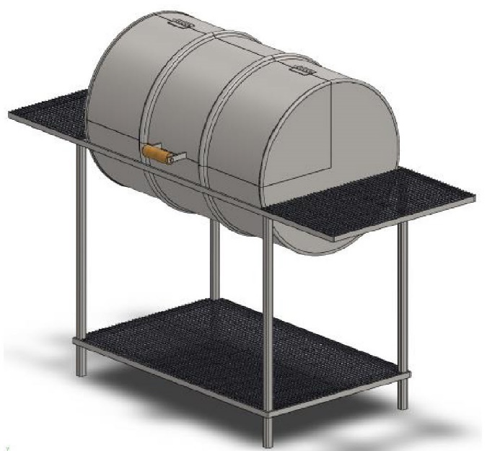
Length
Width
Height

DOCUMENTING YOUR PROJECT – ELECTRONIC PORTFOLIO
Document your project to show the steps you took from beginning to end. Please use Google Slides or Microsoft PowerPoint to create your electronic portfolio. A sample portfolio will be available for reference. Submit your portfolio by April 24th.

Your electronic portfolio must include the following:
- Your school, team name, team members, instructor, and the division you’re entering.
- The inspiration and intent behind your project
- The function of your project (Utilitarian Entries)
- Conformance of your project to the size requirement
- Your project timeline and the steps you took
- The processes, tools, and techniques you used in your project
- Your fit up before welding, and the methods you used to preserve critical dimensions and geometric features such as squareness, straightness, flatness, perpendicularity, etc.
- Your weld processes, quality and size
- The challenges you encountered and solutions you employed

Your portfolio can include the following to support your project:
- Photos
- Video
- Drawings
- Written descriptions

PRESENTING YOUR PROJECT
Each team will give a 2-to-3-minute presentation about its project for the contest judges. The presentation gives the judges a chance to look at the project in more detail, and ask about your design, process steps, fabrication challenges and solutions. The judges will review portfolios before the event.

JUDGING
Your project will be rated in the four categories below along with the corresponding point values for a total of 100 points.
- Design – 30 points
- Portfolio – 20 points
- Presentation – 10 points
- Craftsmanship – 40 points

JUDGING CRITERIA FOR WELDS
The following discontinuities will be considered defects for the purpose of this contest:

- Voids, Cracks, and Inclusions
  - Undercut – Greater than 1/32 inches in depth, any length
  - Porosity – Sum of diameters of holes equals ¼ inches or more on entire project
  - Cracks – Any
  - Slag Inclusions – Any
- Size and Contour
  - Convexity or Concavity – 3/32 inches or greater, any length in any location
  - Unequal Leg (Fillets) – Greater than 1/16 inches, any length in any location
  - Appropriate Size (Fillets) – Leg size = thickness of thinner member
  - Underfill (Groove Welds) – Greater than 1/32 inches in depth, any length
  - Reinforcement (Groove Welds) – Greater than 1/8 inches, any length
- Finish
  - Lack of Finish – Slag, wire, or weld spatter in any amount

EVALUATION RUBRIC

Design
- Criteria
  - For Utilitarian Designs: Your design lends to the efficient function of your project OR For Artistic: Your design lends to the aesthetic impact of your project
  - Your process/tool choices support your design intent
  - Your materials/technique choices support your design intent
- Points Value
  - Sub: Less than 6.99
  - Basic: 7.00 – 7.99
  - Good: 8.00 – 8.99
  - Excellent: 9.00 – 10.00
- Multiplier
  - Times 3

Portfolio
- Criteria
  - Your portfolio shows the evolution of your project, from start to finish
  - Your portfolio details the processes, tool, and techniques you used
  - Your portfolio shows the function of your project Points Values
- Point Values
  - Sub: Less than 6.99
  - Basic: 7.00 – 7.99
  - Good: 8.00 – 8.99
  - Excellent: 9.00 – 10.00
- Multiplier
  - Times 2

Presentation
- Criteria
  - You clearly explain the inspiration and intent behind your project
  - You clearly describe the processes, tools, and techniques used
  - You reflect on challenges and lessons learned throughout the project
- Point Values
  - Sub: Less than 6.99
  - Basic: 7.00 – 7.99
  - Good: 8.00 – 8.99
  - Excellent: 9.00 – 10.00
- Multiplier
  - Times 1

Craftmanship
- Criteria
  - Your weld processes serve your design intent, welds are free of defects
  - Your cut processes serve your design intent and are well executed
  - Your fit up preserves critical dimensions and geometric features
- Point Values
  - Sub: Less than 6.99
  - Basic: 7.00 – 7.99
  - Good: 8.00 – 8.99
  - Excellent: 9.00 – 10.00
- Multiplier
  - Times 4

